**Data Analyst Nanodegree**

**Explore weather Trends**

**SQL Commands for Extracting Data:**

**1- List the cities in Saudi Arabia to check the nearest one’ I am in Saudi Arabia in Riyadh city’:**

Select * from city_list

Where

country like 'Saudi%';

**2- Extract ‘Riyadh’ city data to check the available data, noted that the year started from ‘1843’:**

select * from city_data

where

city='Riyadh';

**3- Extract Global data with City Date for the matching years starting from ‘1843’:**

select global_data.year,

concat(global_data.year ,' ',(global_data.year - 9) ) period,

global_data.avg_temp global_AT,

city_data.avg_temp city_AT

from city_data, global_data

where

city_data.city='Riyadh'

and city_data.year=global_data.year;

Download and save in CSV file

**Moving Averages:**

Open CSV file with Excel, add 2 columns one to the Global moving average and other to Riyadh moving average.

Calculate the moving average for the both temperature columns for 10 years by AVERAGE Formula in Excel “AVERAGE(E2:E11)”

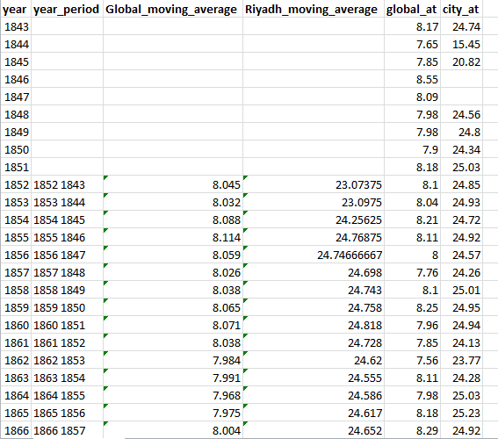

**Line chart:**

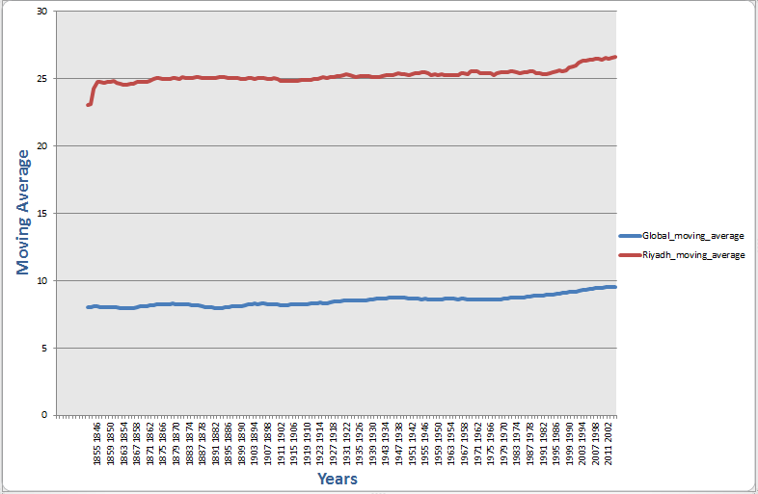

**Observation:**

1. If we compare the Riyadh average temperature to the global average temperature, Riyadh is hotter over the years.
2. The chart and data indicate that there is a rise in temperature both in the city of Riyadh and in the world, meaning that the world becomes hotter.
3. The Riyadh average temperature is increasing at a lower rate compared to global average temperature.
4. In the last years, exactly from (1899 -1890) the moving average temperature in Riyadh increased at a rapid rate. In contrast, the rise was steady on the global moving average temperature.